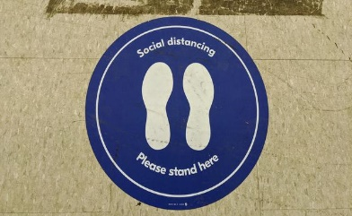
“The New Norm”
See, I am doing a new thing!
Isaiah 43:19

Wabash Women’s Ministries
Fall Retreat at
Wabash Park Camp & Retreat Center
October 9-10, 2020
Guest Speakers:
Vickie Reynen
Sherry Cahill
?
Friday:
7:00 PM Bonfire at the WMI Shelter
Hotdogs & drinks will be provided
Bring snacks to share in individual serving sizes!

Saturday:
9:00-9:45 Continental Breakfast in Dining Hall
10:00-10:45 Speakers-WMI Bldg/Youth Bldg/Dining Hall
11:00-11:45 Speakers-WMI Bldg/Youth Bldg/Dining Hall
12:00-12:45 Lunch in Dining Hall
1:00-1:45 COVID Bingo! In Dining Hall
2:00-2:45 Speakers-WMI Bldg/Youth Bldg/Dining Hall
(Golf carts will be available if transport between buildings is needed)
“See, I am doing a new thing! Now it springs up; do you not perceive it? I am making a way in the wilderness and streams in the wasteland.”
Isaiah 43:19

Please mail registration forms to:
Connie Buterbaugh
3714 Greenbriar Dr
Columbus, IN 47203
812-371-8186

Fall Retreat Registration
October 9-10, 2020
Deadline: October 2

Name
Address

Phone
Email
Church
Registration Fee (per person): $25

Need Housing? □YES (check option below) □NO
□ Bethany – single room (sleeps 1-2) * $45
□ Bethany - double room (sleeps 3-4) * $55
□ Wesley Inn (sleeps 13) * fee is for the whole bldg $200
□ IN/IL – Rustic (no linens or bathroom) $20
* linens provided, the costs listed above are per room
Please list people you will be rooming with (if applicable):
TOTAL COST DUE: $

Make checks payable to: Wabash Women’s Ministry
(mail payment with registration form to Connie Buterbaugh, pay at the door, or register online at www.wabashconference.org or https://www.facebook.com/WabashConferenceWMI/)

Do you have any dietary restrictions? Please explain

